In this here, our latest of posts, we come to you after a one-week hiatus. Of course, as we all know, the maxim goes that consistency is key. However, what with an apartment move on the books, I kindly excused myself to build some furniture. Excellent choice. Now, with labor day weekend here, we have all the time in the world to do otherwise, and get in to some numbers.

So, without further ado, let me introduce this week’s topic – python with finance, or finance with python. Whichever way you will have it.

I have borrowed generously for this discussion from Finance365’s training on the same topic, and hosted on O’ Reilly Media website. And, without giving away the key to beating the financial market, because I’m yet to see that key myself, I’m going to tell you how to interpret some basic numbers. Some of the stocks and etfs used here are ones I actually hold myself. However, ratios, balances, and amounts may vary, and are not discussed here. In addition, this discussion focuses primarily on stocks. For a balanced portfolio containing treasury bonds, you may have to look elsewhere 😊

Now, to begin the discussion:

**Part 1: Returns**

Yahoo may well have lost its mojo from its initial stature as a bigwig in the web-based industry. However, yahoo finance still has clout! And is the medium even our finance professors used when telling us how and where to pull stock price information from. Let us begin the discussion by looking at the SPY etf product.

Fig 1 below is the simple returns, daily – SPY.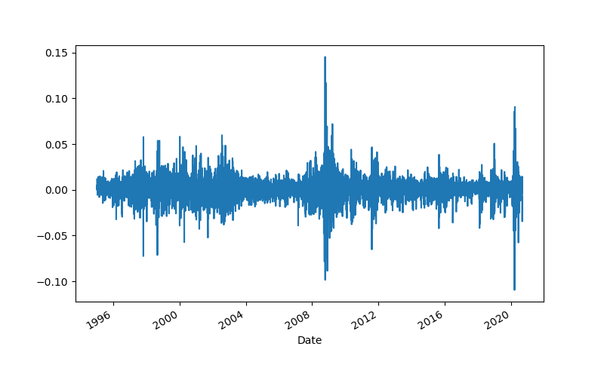

And, Fig 2, log returns, also daily, also SPY

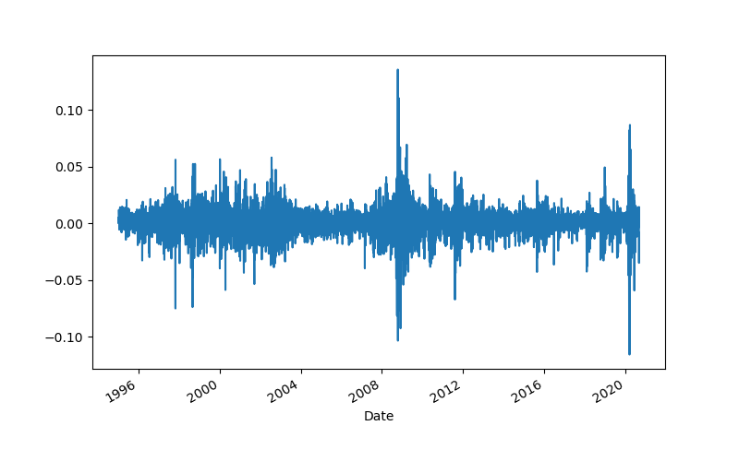

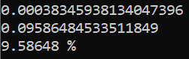

Here are two sets of visuals. The first, is a graph of volatility or oscillations in the market returns for SPY, measured logarithmically, and annually. The next shows us numbers for the daily log returns, annual log returns, and percentage annual log returns for SPY – nearing roughly 9.58% per year.

Printed below are the annualized means

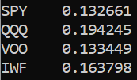

Followed by the standard deviations of the annualized stock prices

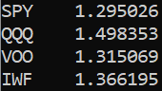

This captures the spirit of the reward risk ratio that so defines most of what we do with our finance. A quick glance shows that of the etfs listed, the low risk low reward is epitomized in SPY, and high risk – high reward in the QQQs.

**Part 2: Risk**

Next, we move to directly examining risk.

Figure 3: covariance matrix, annualized

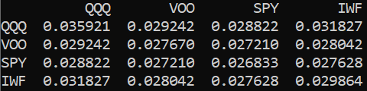

Figure 4: correlation matrix, daily returns

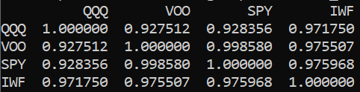

Figure 5: portfolio variance and volatility

The first metric is the portfolio variance, annualized. While the other two are the standard deviation, or square root of the first metric.

the next part assumes equal parts distribution, ie 1/4 per stock:

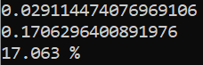

**Part 3: Allocation, Optimization**

And now, the moment we’ve all been waiting for. Here below are the normalized returns from the stocks we’ve picked in our basket.

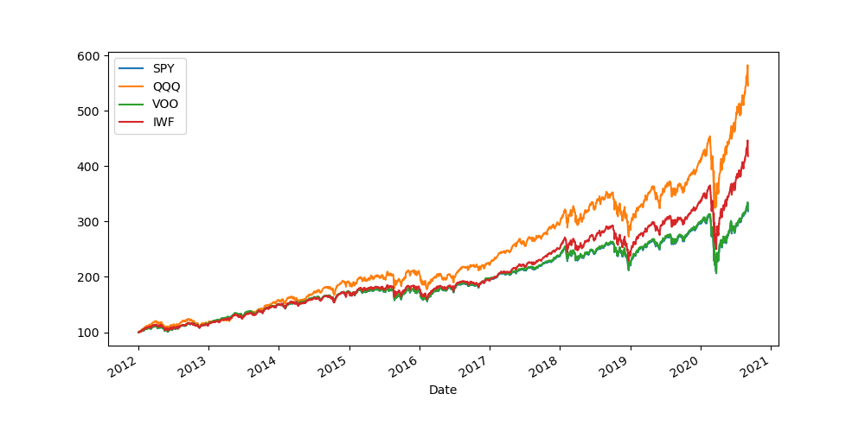

Printing some crucial summary stats we need for generating the efficient frontier:

1. Mean
2. Covariance
3. Correlation

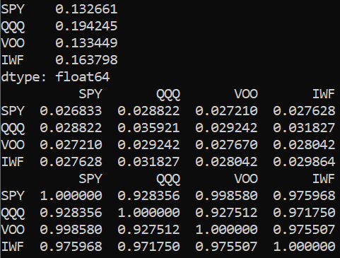

Weights Simulated, and plotted

After running a 1000 simulations of portfolio weights, allocated to individual funds, we end up with return – volatility combinations as shown below.

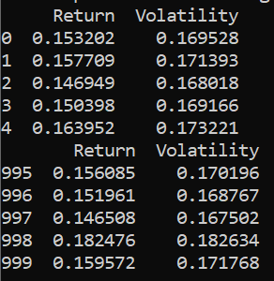

Plotting these combinations gives us the actual efficient frontier, we want to use to optimize our portfolio allocation decisions:

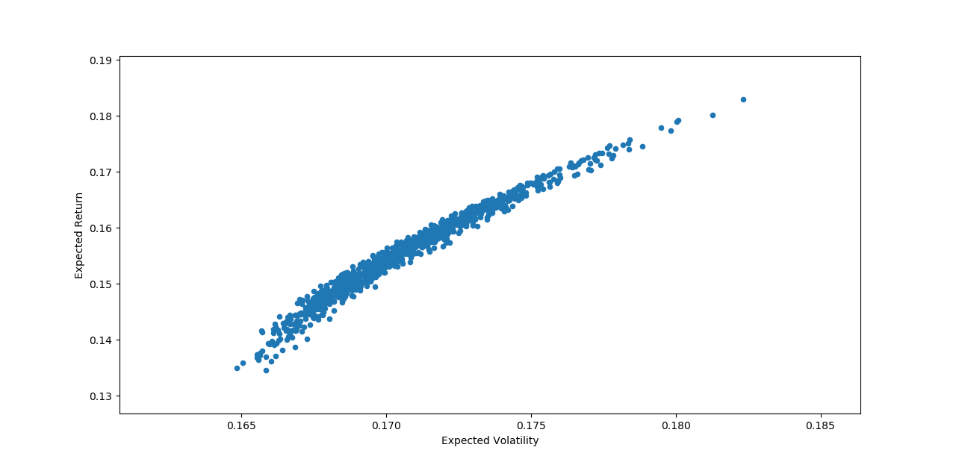

**Part 4: CAPM**

This next segment is restricted to the QQQ’s, and calculates and reports on the Sharpe ratio, as a measure of stock variation with respect to the market:

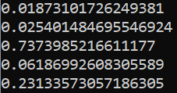

The metrics reported in the above picture, in order, are:

1. Covariance with market
2. Market variance
3. QQQ’s beta
4. QQQ’s expected return
5. Sharpe ratio

**Part 5: Simulation, profits**

Closing the discussion with the stock we opened the discussion with

SPY: historical price trend

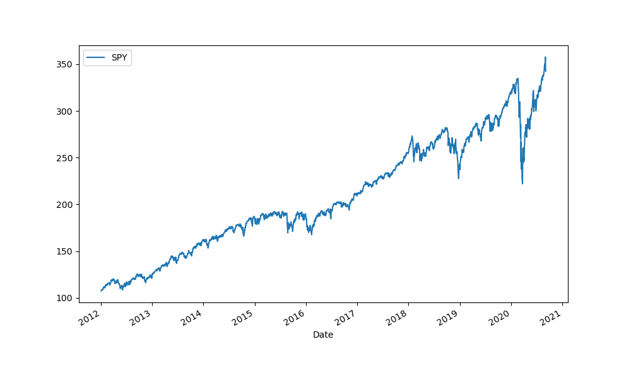

Historical Log Returns: SPY

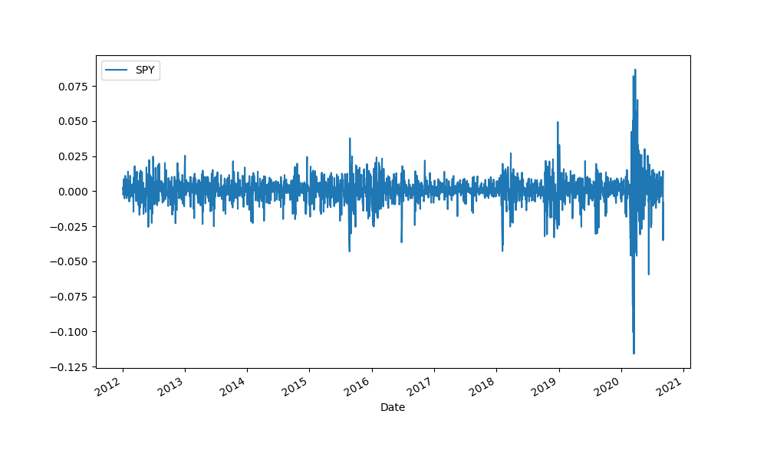

We now use our existing stock prices to predict the upcoming day’s stock prices.



Forecasts and simulations, 10 iterations of how the market can look going forward, based on historical trends in SPY stock price.

